HW04 Secret Key Encryption Lab

**Task 1: Frequency Analysis**

Using the online tool at <https://math.dartmouth.edu/~awilson/tools/frequency_analysis.html> I performed frequency analysis by comparing frequencies and making guesses.

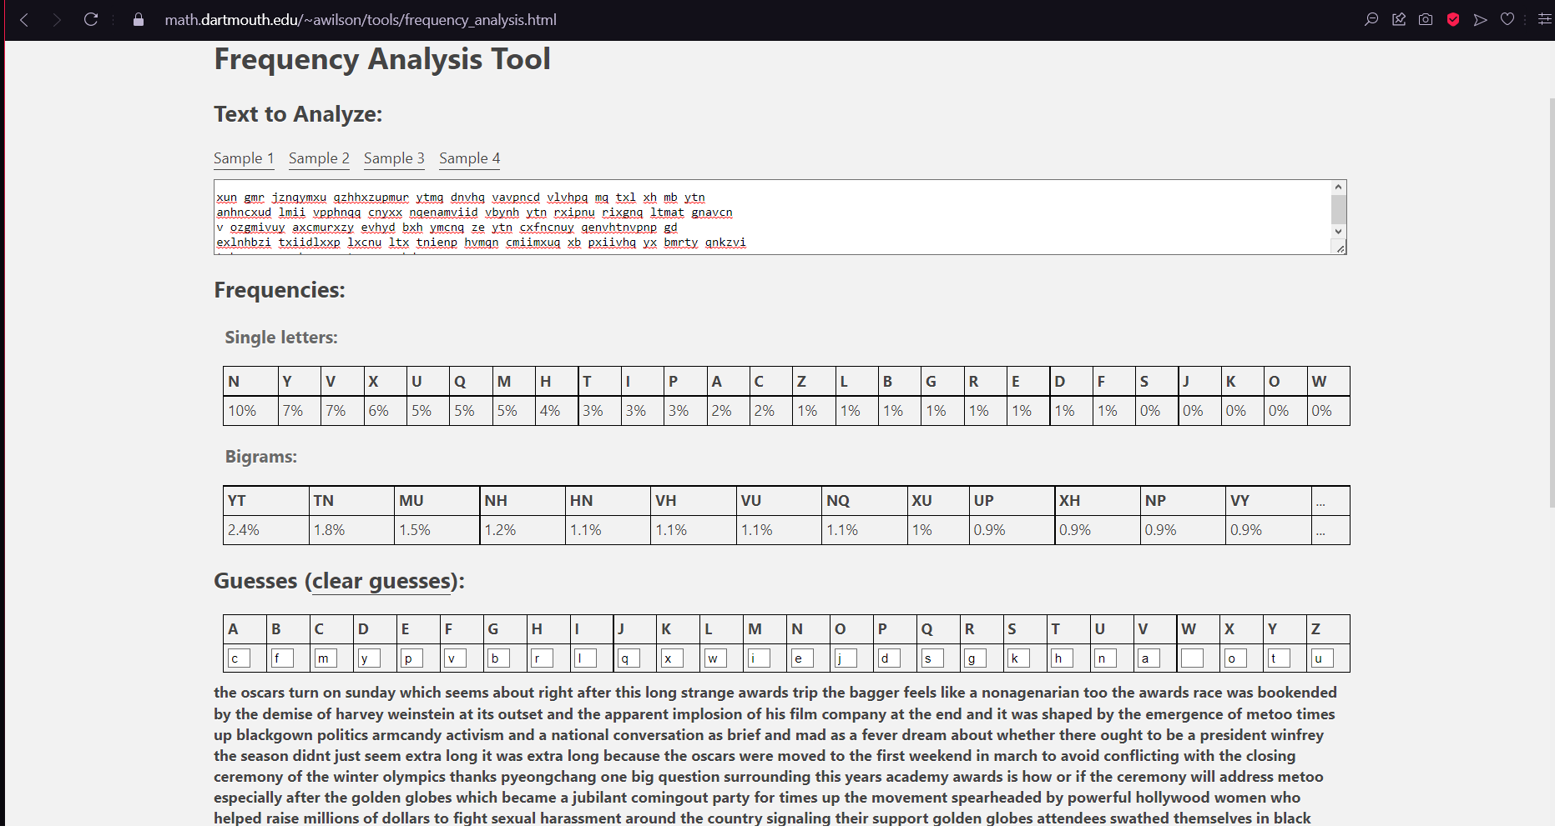

**Task 2: Encryption using Different Ciphers and Modes**

This is the plaintext from task one.

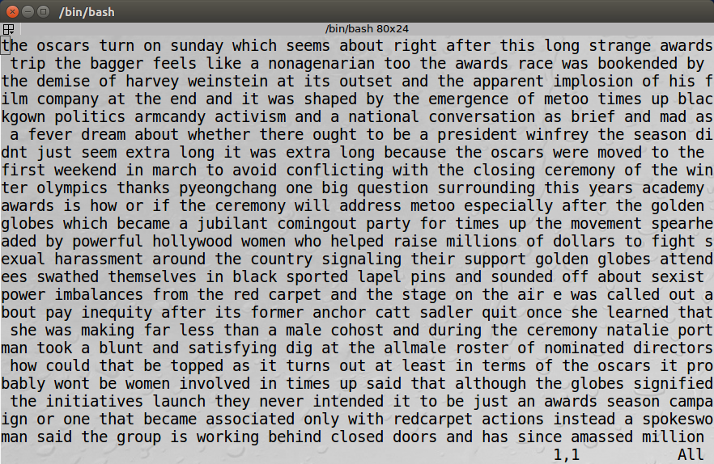

AES-128-CBC Encryption



BF-CBC Encryption



AES-128-CFB Encryption



**Task 3: Encryption Mode – ECB vs. CBC**

Encrypt using ECB and CBC 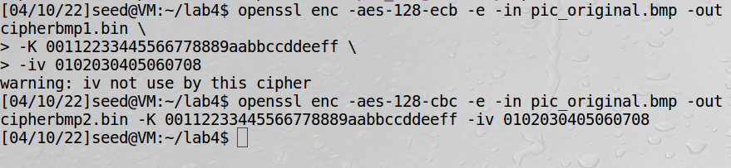

Make encrypted image visible by combining with normal header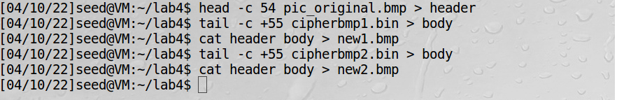

Using EOG to view the images, here are the results

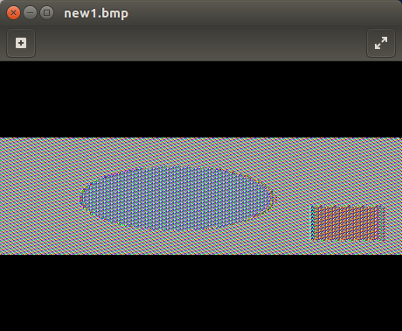 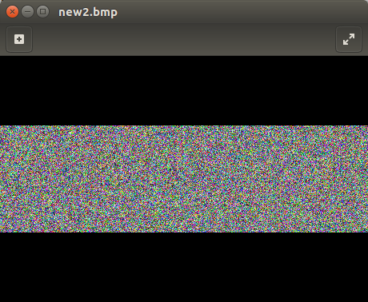

As you can see, images encrypted using ECB can still be seen. A human can very easily tell what the image was about originally. Using CBC, all that remains is static. This makes CBC superior for encrypting images.

Repeated Experiment with image of my choice:

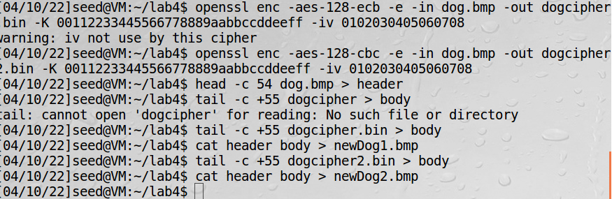

Here are the results: (from left to right: original, EBC, CBC)

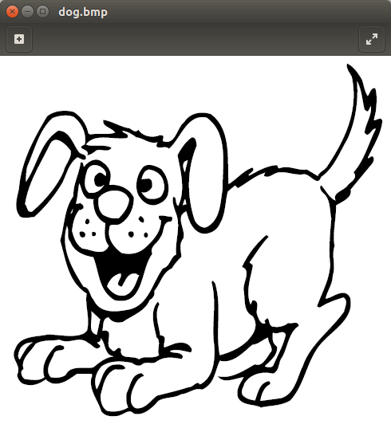 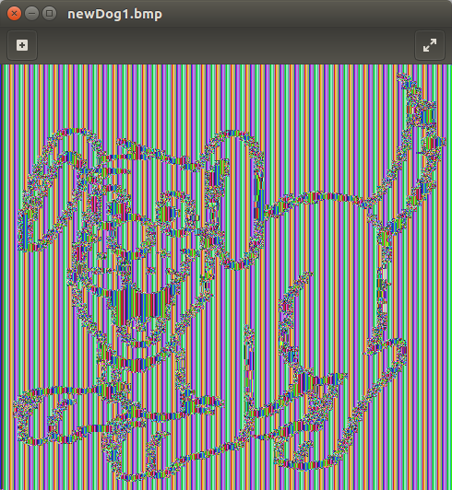 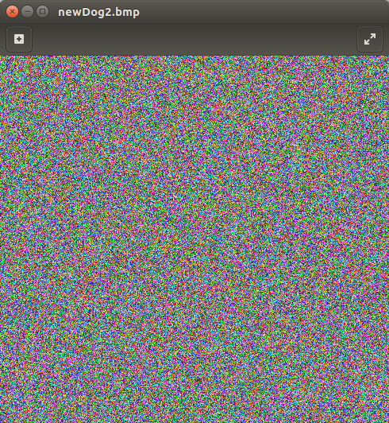

The results are the same. EBC shows a faint silhouette of the original, while CBC shows no visible pattern.

**Task 4: Padding**

The original file has 26 bytes.

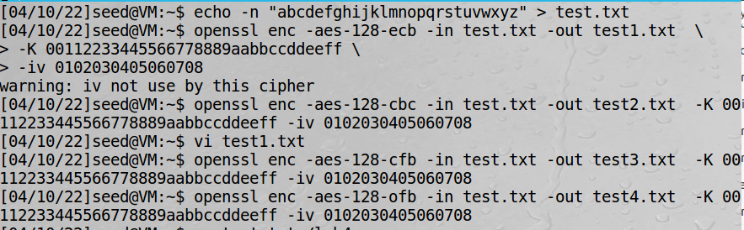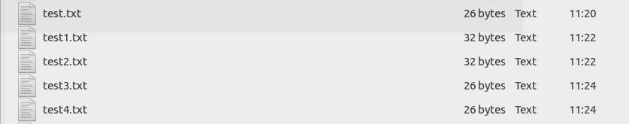

ECB – size is 32 bytes. The file was padded.

CBC – size is 32 bytes. The file was padded.

CFB – size is 26 bytes. The file was not padded.

OFB – size is 26 bytes. The file was not padded.

The reason ECB and CBC are padded, while CFB and OFB are not padded has to do with stream vs block ciphers. Since ECB and CBC are block ciphers, files must be padded until a multiple of the block size is reached. CFB and OFB are stream ciphers, so they do not need to be padded.

The next step is to make three files of byte sizes 5, 10, and 16.

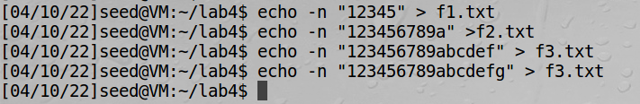

Encrypt using AES-128-CBC mode.

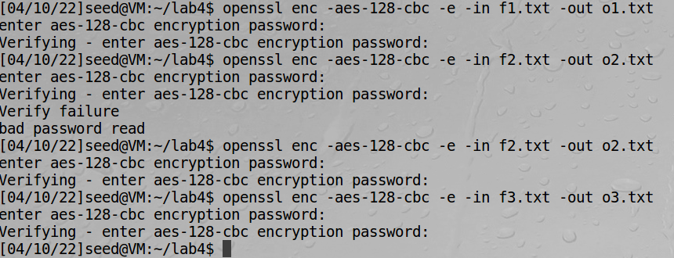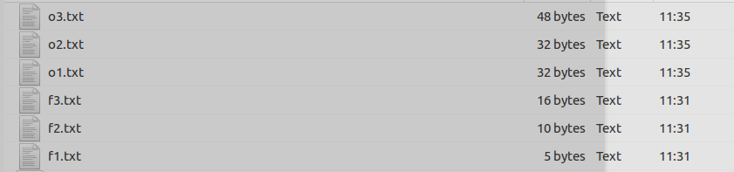

The encrypted files are a multiple of 16, with o1.txt and o2.txt being 32 bytes and o3.txt being 48 bytes.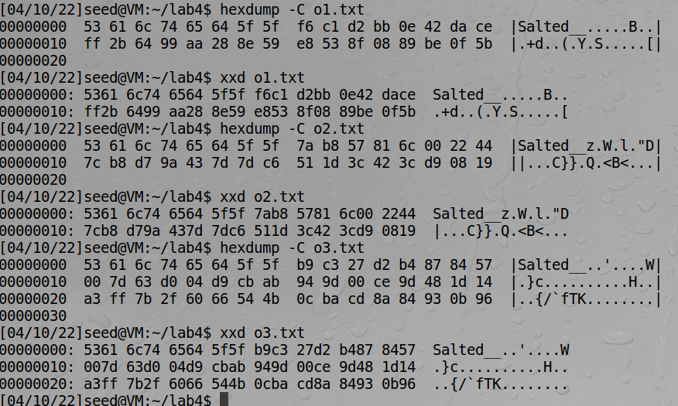

**Task 5: Error Propagation – Corrupted Cipher Text**

For the sake of simplicity, the file is filled with the lowercase alphabet “abcde…xyz” repeated until the file size exceeded 1000 bytes (actually, it is closer to 1.2k bytes but that is good enough). Key used is “00112233445566778899aabbccddeeff”, and IV is “aabbccddeeff998877665544332211”.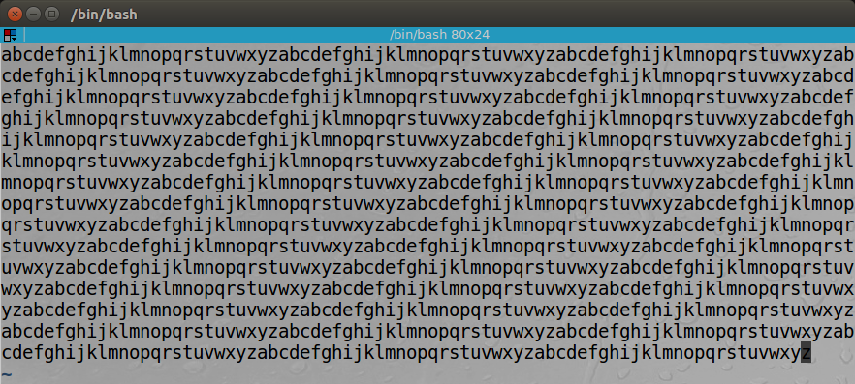

Corr1: CBC. Corr2: ECB. Corr3: CFB, Corr4: OFB.

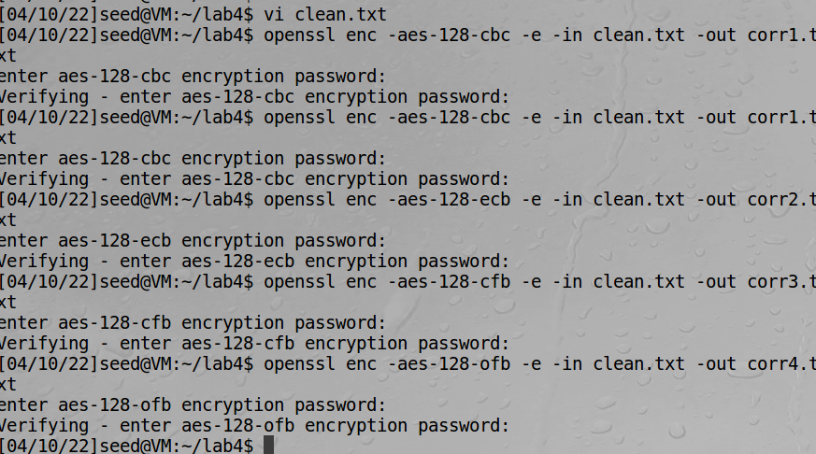

Corr1 Before/After:

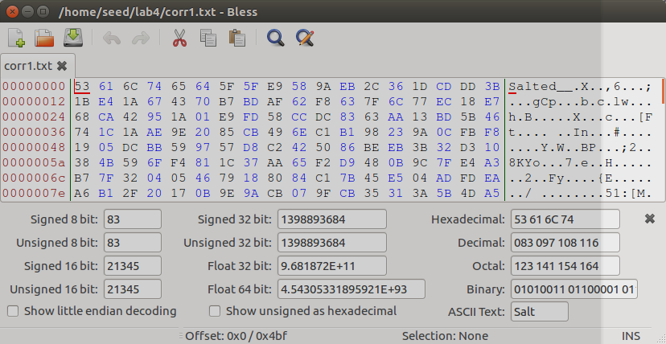 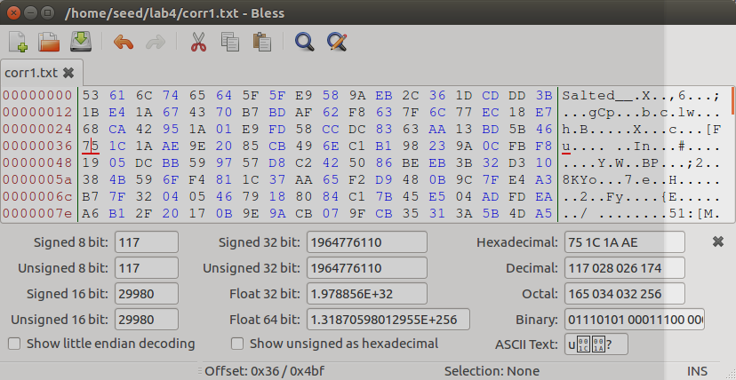

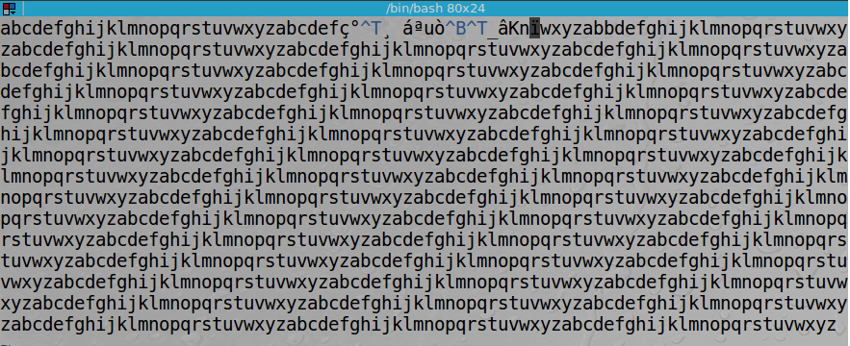

Corr1 Observation: For CBC, the 55th byte is corrupted while everything else is normal.

Corr2 Before/After:

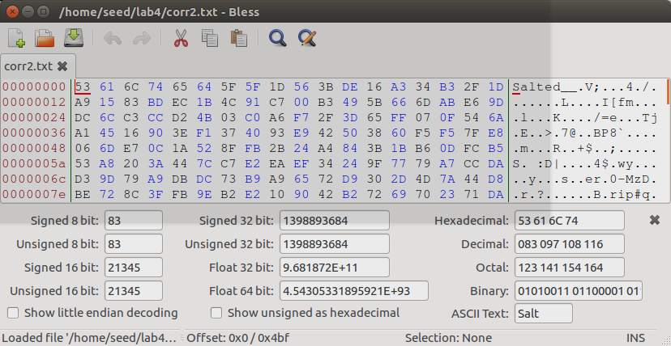 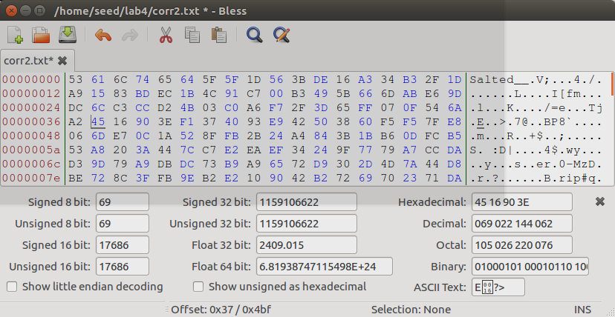

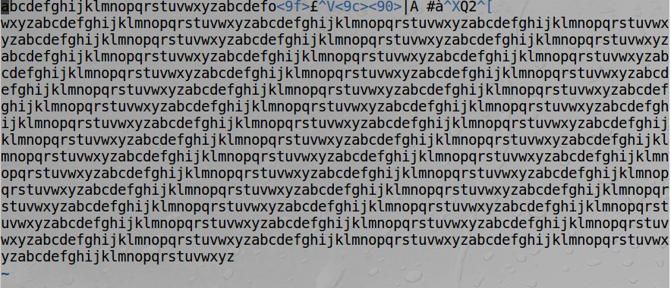

Corr2 Observation: For ECB, the 55th byte is corrupted while everything else is normal.

Corr3 Before/After:

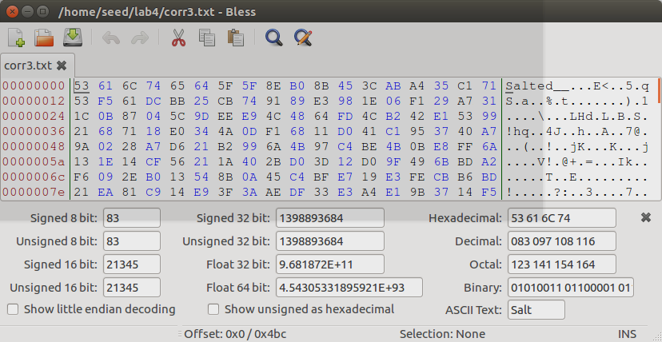 

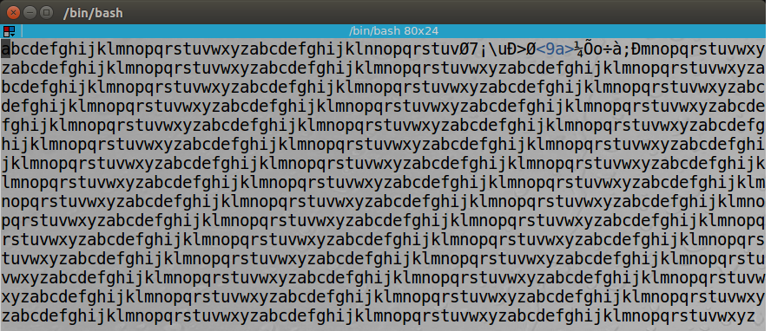

Corr3 Observation: For CFB, it looks like a byte before the 55th byte and the 55th byte were corrupted while the rest is normal.

Corr4 Before/After:

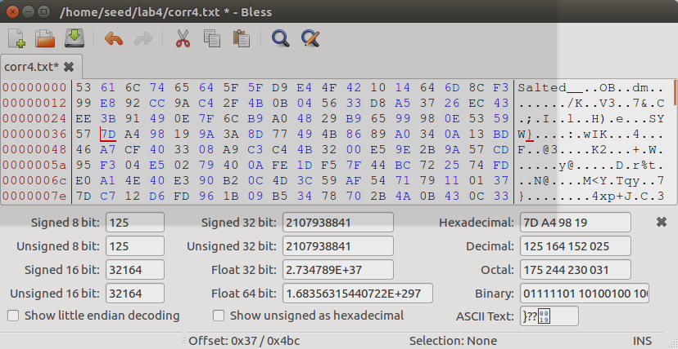 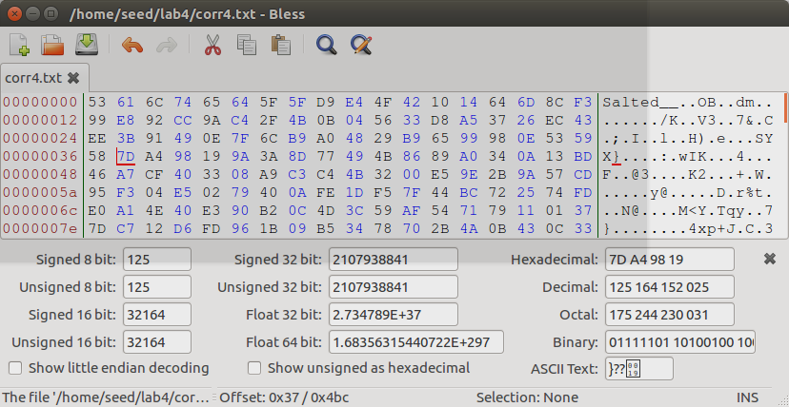

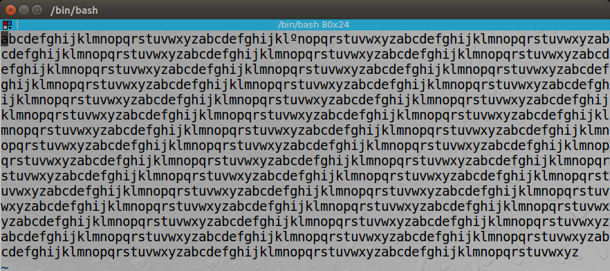

Corr4 Observation: For OFB, it appears to be only one bit within the 55th byte that got corrupted.

Before attempting this experiment, I thought that corruption would influence the entire file and ensure that nothing can be retrieved. In practice, it appears that the majority of data can still be retrieved with the correct key despite corruption of a single byte. CFB and OFB performed better in preserving data than CBC and ECB encoding. This is likely due to the difference between stream and block ciphers, where damaging the integrity of a block will affect the entire block, while affecting a stream will only affect the corrupted byte.

**Task 6: Initial Vector (IV) and Common Mistakes**

**7.1 Task 6.1**

extraTest (IV 1) and extraTest1 (IV 1) are identical since they were encrypted with the same IV.

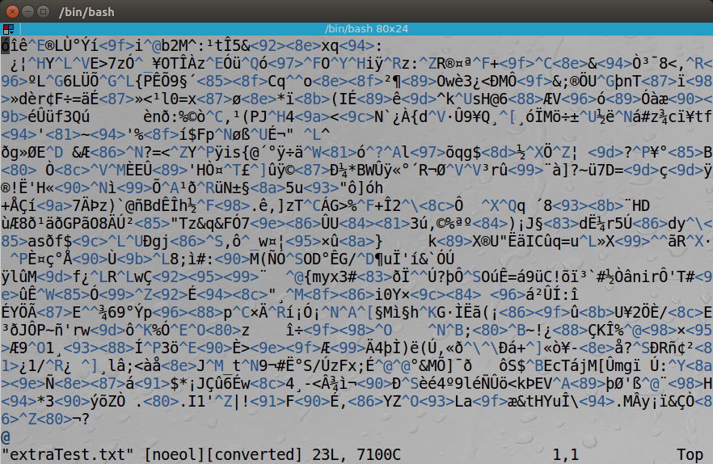 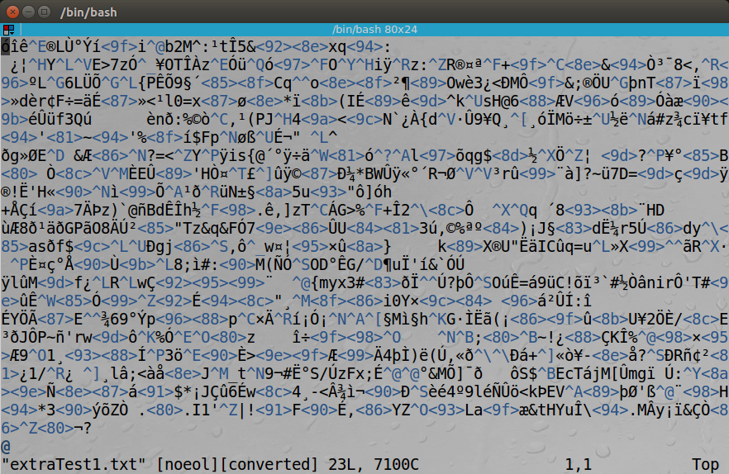

extraTest2 used a slightly different IV (IV 2), so the encrypted result is different.

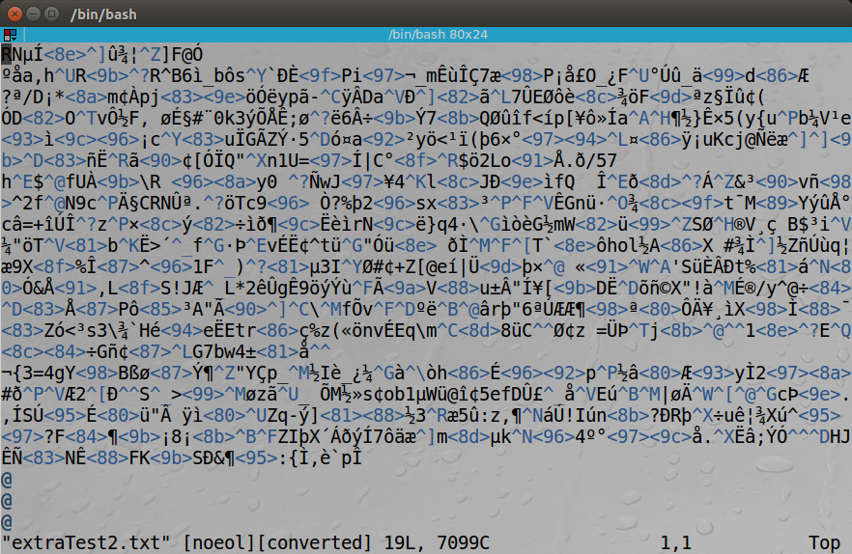

IV needs to be different every time. If the same IV is used every time, it will become easy for an attacker to analyze the pattern whenever a plaintext is reused.

**Task 6.2. Common Mistake: Use the Same IV**

Based on the information given, it appears to be very likely that P1 and P2 share the same ending (since both C1 and C2 end with c159). Since I know that P1 ends with an exclamation mark, I can guess that P2 also ends with an exclamation mark.

If this experiment is done using CFB instead of OFB, we can only decipher the first block of the message.

**Task 6.3. Common Mistake: Use a Predictable IV**

Since I know that the plaintext is either “yes” or “no”, I just need to guess one of the two and then predict the IV from the ciphertext. Then, I can verify my guess by encrypting my plaintext guess with the known IV and comparing the result.

**Task 7: Programming using the Crypto Library**

The key is: “entropy#########”

I used java for this task. The main method uses scanner to read the dictionary text file and runs a loop that continues if there are words left or the key has not been found. The loop calls pad(), encrypt(), and compare() to see if there is a match. Once the key is found, it prints the key to console.

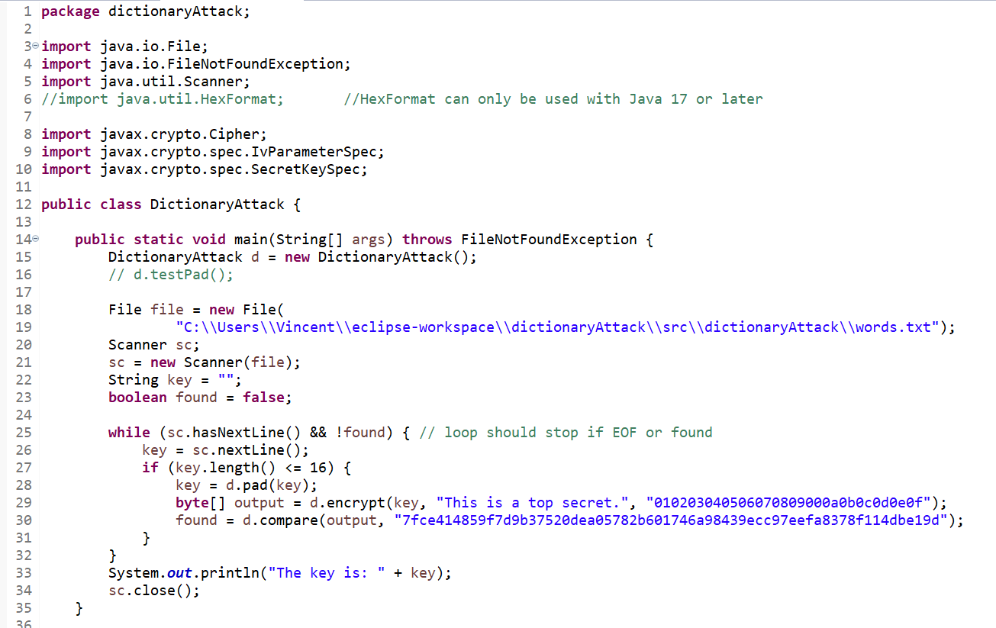

The compare method calls compareHelper(), which checks the two byte arrays and returns true if they are exactly the same.

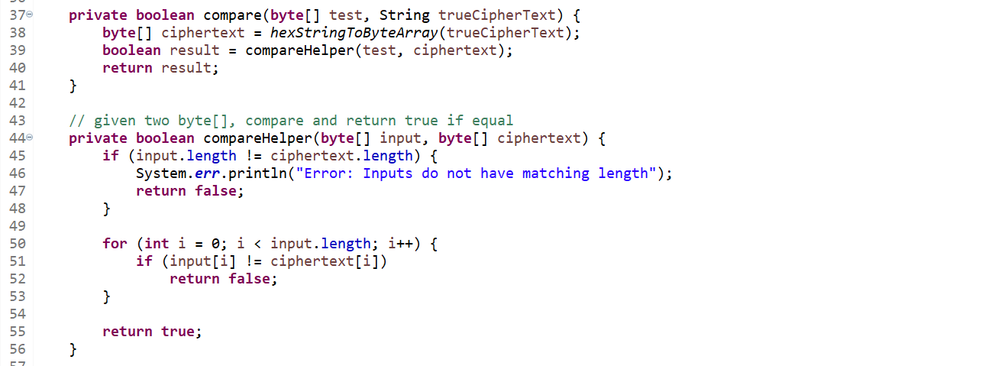

A few methods for testing are cut off here. The pad() function adds # symbols until the input string reached size 16. The encrypt() function performs AES-128-CBC encryption with the given parameters and returns an encrypted byte string. The hexStringToByteArray() function is a workaround for HexFormat, which requires Java 17 or later. It takes a string (which is understood to be in hex format), and converts it into a byte array.

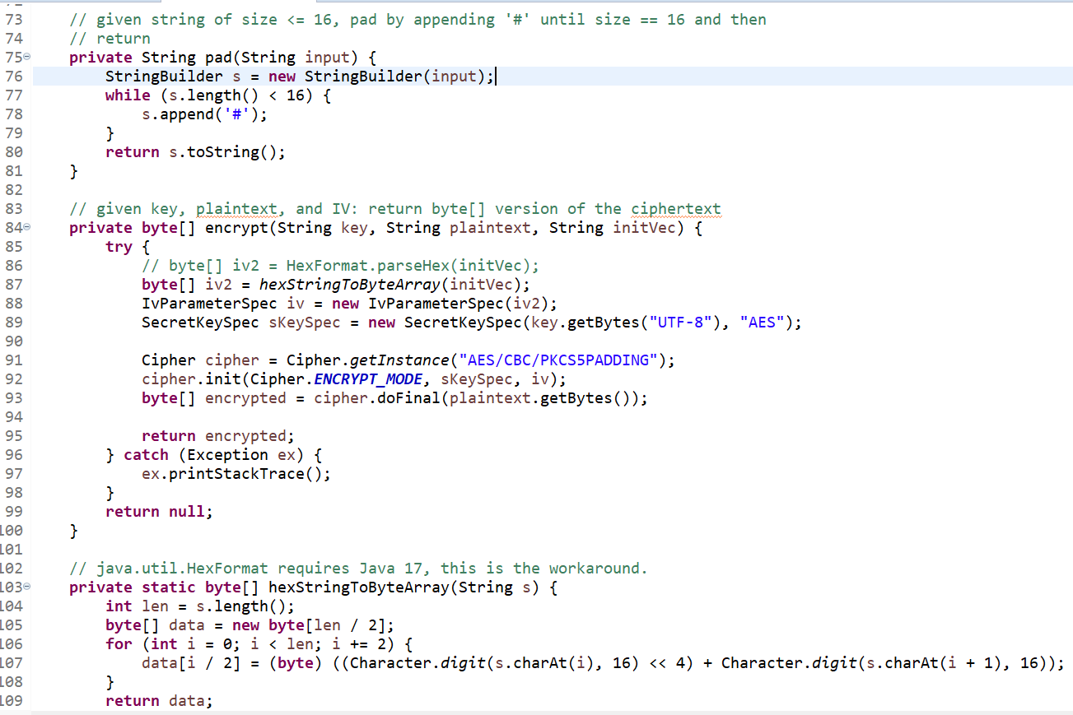

Upon running the program, here is the result.

